**RIPHAH INTERNATIONAL UNIVERSITY, ISLAMABAD**



**Lab 12**

**Bachelors of Computer science – 5th semester**

**Subject:** Operating System Lab

**Submitted to:** Ma’am Kausar Nasreen Khattak

**Submitted by:** Areeba Sadaqat

**Sap Id:** 47633

**Date:** 11th November, 2024

**Lab Tasks**

**Q1:** Which command would you use to find the process ID (PID) of a process named OSLab without running it. After obtaining the PID, which command would you use to kill the process?

**Answer:**

**Command:** pidof OSLab

This will display the PID(s) associated with the OSLab process.

Once you have the PID, you can terminate the process by using the kill command followed by the PID:**Command:**

kill <PID>

**Q2:** How would you write a script that uses a signal trap to handle specific signals, and what is the purpose of a signal trap in such a script?

**Answer:**

**Code:**



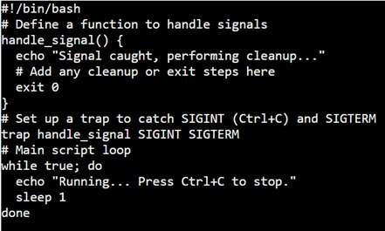

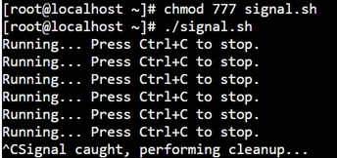

**Purpose:**

A signal trap enables a script to catch signals like SIGINT (interrupt, usually triggered by pressing Ctrl+C), SIGTERM (terminate), and others. This allows the script to handle cleanup activities, such as saving data, closing files, or releasing resources, before shutting down properly.